3.61: a) The expression for the range, as derived in Example 3.10, involves the sine of twice the launch angle, and
and so the range is the same. As an alternative, using 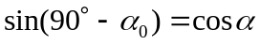 and 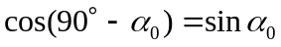 in the expression for the range that involves the product of the sine and cosine of 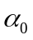 gives the same result.
b) The range equation is 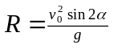. In this case, 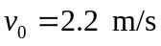 and 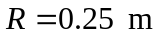. Hence or 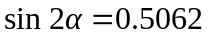; and 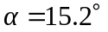 or 

